1.Introduction
An important property of chemical systems, like organic molecules, is their HOMO-LUMO gap which is the energy difference between the highest occupied molecular orbital (HOMO) and lowest unoccupied molecular orbital (LUMO). This is a fundamental descriptor of the electronic structure of a molecule. It governs key properties such as reactivity, optical absorption and charge transport characteristics. As a consequence, accurate determination of the HOMO–LUMO gap is essential for rational molecular design in chemistry, materials science, and molecular engineering.
Experimentally, the HOMO–LUMO gap can be approximated through optical spectroscopy. In UV–Vis absorption spectroscopy, electron excitation from the ground state (associated with the HOMO) to excited states (related to the LUMO) produces an absorption onset, or optical band edge, whose energy corresponds to the optical gap. Similarly, photoluminescence spectroscopy captures the energy released during radiative relaxation. Although the optical gap differs slightly from the true orbital energy gap due to excitonic effects, solvent interactions, and vibrational broadening, it provides a practical and widely used experimental proxy for frontier-orbital energetics. However, experimental measurements require synthesized, purified materials and are not suitable for large-scale exploration of hypothetical chemical structures.
An alternative way to get the HOMO-LUMO gap is with computational chemistry, such as Hartree-Fock and Density functional theory (DFT). Despite their accuracy, these quantum chemical methods are computationally expensive and scale poorly with molecular size and dataset volume. These factors are the motivation to search for faster predictive approaches to get insight in the electronic properties of molecules.
Machine learning (ML) provides a compelling strategy to overcome these computational limitations. After training, ML models can predict electronic properties with negligible computational cost compared to traditional quantum chemistry. Recent work has demonstrated that methods such as gradient-boosted decision trees, kernel regressors, and graph neural networks (GNNs) achieve mean absolute errors well below 0.2 eV in HOMO–LUMO gap prediction tasks. Crucially, large-scale quantum-chemical datasets like QM9, which contains orbital energies for over 130,000 small organic molecules, enable the development and benchmarking of ML models with the data volume required for robust learning.
https://pubs.acs.org/doi/10.1021/acs.jcim.5c01412
https://pubs.acs.org/doi/10.1021/acs.jpca.0c05969
Beyond property prediction, ML also enables generative molecular design. Traditional experimental workflows require iterative synthesis and characterization to identify molecules with desired electronic properties. ML-based generative models, however, make it possible to explore hypothetical chemical structures, optimize properties in silico, and drastically reduce the number of costly experiments. This accelerates molecular discovery pipelines, supports safer design exploration, and opens chemical regions that would be impractical to investigate experimentally.
In this study, we pursue a two-fold objective. First, we build predictive models for HOMO–LUMO gap estimation using both LightGBM, a high-performance gradient boosting framework and a graph neural network (GNN) that learns molecular representations directly from graph topology. Second, we integrate the predictive GNN into a conditional variational autoencoder (CVAE) to generate novel molecular structures with user-specified target HOMO–LUMO gaps. This framework enables both accurate property prediction and inverse molecular design, supporting accelerated discovery workflows in electronic-structure–driven molecular design.

3.Methodology
3.1 LightGBM Regression Model
LightGBM is a gradient-boosting framework based on decision trees that uses histogram-based learning. It uses also leaf-wise tree growth to achieve high predictive accuracy with efficient computation, this is different from other ML models like XGBoost which uses level-wise growth, figure. Unlike traditional level-wise boosting algorithms, LightGBM grows trees by expanding the leaf that maximally reduces the loss, which allows it to model complex nonlinear relationships while maintaining scalability for large datasets. These characteristics make LightGBM particularly well suited for molecular property prediction tasks, where complex structure- property relationships must be captured from high-dimensional descriptors. 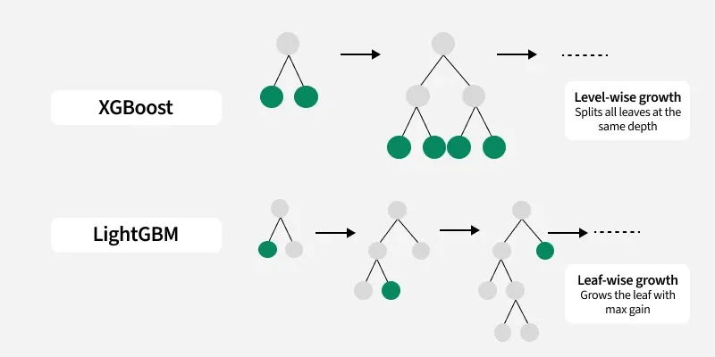
3.1.1 Molecular Representations
To apply LightGBM to HOMO–LUMO gap prediction, molecules were converted into numerical descriptors. This could be done by using the SMILES representation which is also given in the QM9 database. SMILES (Simplified Molecular Input Line Entry System) is a text-based language using ASCII characters to represent chemical structures as short strings, allowing computers to easily understand and process molecular information. This smiles could be given to RDkit which produces chemical descriptors/ features. (cite) These features provide a fixed-length representation for each molecule, enabling the use of gradient-boosted tree models that require tabular input.
    - Hyperparameter Optimization
We optimized LightGBM hyperparameters using Optuna, a Bayesian optimization framework that efficiently explores high-dimensional search spaces. The tuning process included: number of leaves, maximum tree depth, learning rate, feature and bagging fraction, minimum child samples.
The objective function minimized the mean absolute error (MAE) on validation folds within the inner loop of nested cross-validation. Optuna's Tree-structured Parzen Estimator (TPE) sampler was used to balance exploration and exploitation during search.
    - Nested Cross-Validation
To obtain an unbiased estimate of generalization performance, we used nested fold cross-validation. The outer loop splits the data into train/test partitions and evaluates final performance. For each outer training fold, the inner loop performs hyperparameter tuning with Optuna. The best hyperparameters from the inner loop are retrained on the full outer training fold and evaluated on the corresponding test fold. This procedure prevents information leakage between hyperparameter tuning and model evaluation, ensuring a robust assessment of predictive performance.
3.1.4 Final LightGBM Model
After completing nested cross-validation, we selected the best-performing hyperparameter configuration (averaged or most frequent across outer folds) and retrained a final LightGBM model on the entire dataset. This final model was used only for comparison with the GNN model and was not involved in the generative modeling stage.

